PROJECT: 3-STAGE PIPELINED PROCESSOR

SUBMITTED TO: SIR SHOAIB

GROUP MEMBERS:

MAIMOONA BIBI (055)
NATASHA MARYAM (068)
KANWAL NOOR UL AIN (049)

COURSE: COMPUTER ARCHITECTURE

PROJECT REPORT:

Abstract
This project presents the design and simulation of a 16-bit 3-stage pipelined processor based on the RISC-V Instruction Set Architecture (ISA). The processor implements a 3-stage pipeline consisting of Fetch, Decode, and Execute stages to improve instruction throughput compared to a single-cycle design. The system was designed in Verilog HDL and simulated using ModelSim. The results demonstrate successful instruction fetching, decoding of opcodes, and arithmetic execution, validating the advantages of pipelining in digital system design.

Introduction

Project Objective
To design a processor that can execute basic instructions (ADD, SUB, LOAD, STORE) using a pipelined architecture to increase speed and efficiency.
What is Pipelining?
Pipelining is a technique where multiple instructions are overlapped in execution. Instead of waiting for one instruction to finish completely, the processor processes different stages of multiple instructions simultaneously.
- Analogy: It is like a car assembly line where one car is being painted while the next one is having its engine installed.
Why RISC-V?
RISC-V is a modern, open-source instruction set architecture (ISA) that is simple and ideal for learning computer architecture.

System Architecture
The 3 Stages
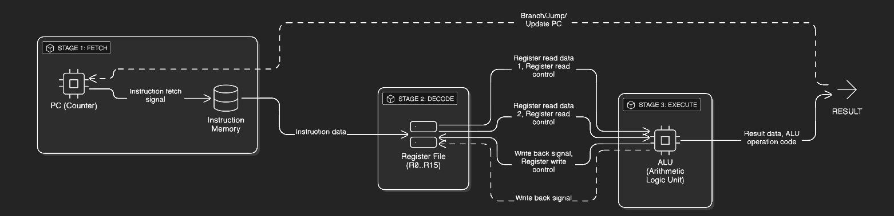
The processor is divided into three main modules:
- Instruction Fetch (IF): Retrieves instructions from memory.
- Instruction Decode (ID): Reads registers and decodes the opcode.
- Execute (EX): Performs ALU operations and writes back results

Implementation Details

3.1 Stage 1: Instruction Fetch (Member 1)
- Description: This stage manages the Program Counter (PC) and Instruction Memory. The PC increments by 1 in every clock cycle to fetch the next instruction.
- Key Modules:
  - pc_unit.v: Handles address generation and reset logic.
  - imem.v: Stores the machine code of the program.
- Challenges Solved: Implemented a stall logic input to freeze the PC when needed.

Start the modelsim:
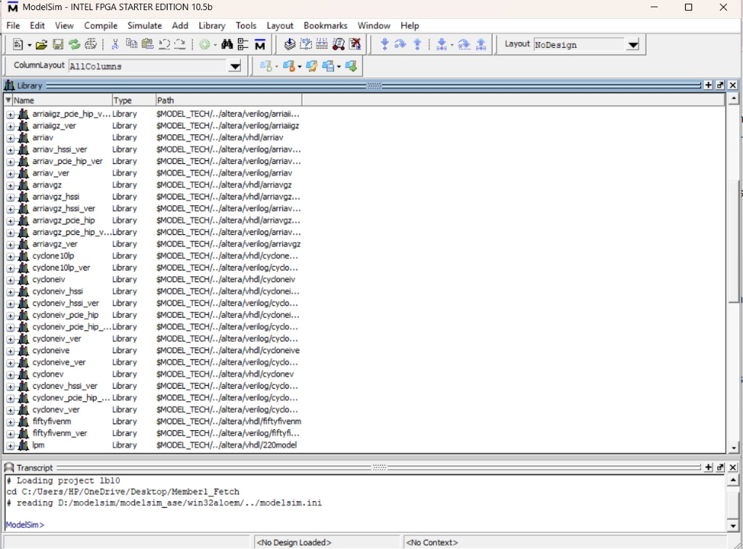

Creating file 1:

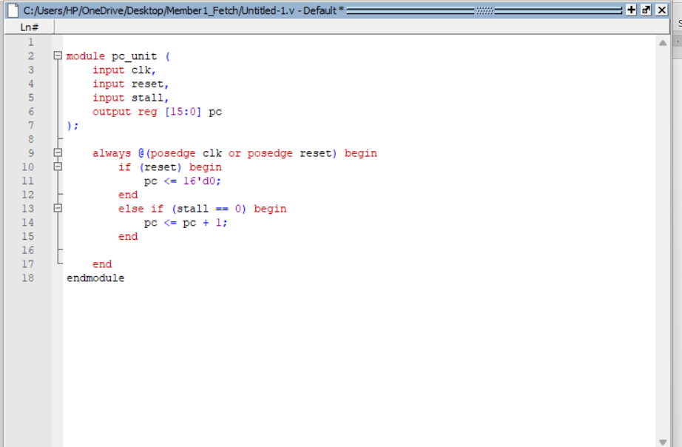
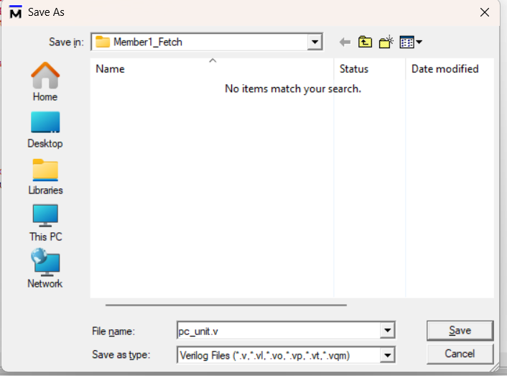

Creating file 2:
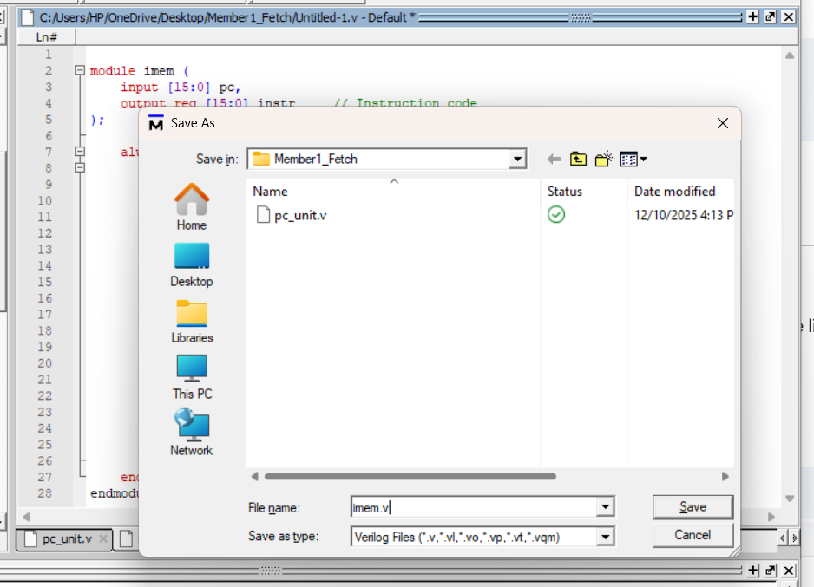

Creating file 3:
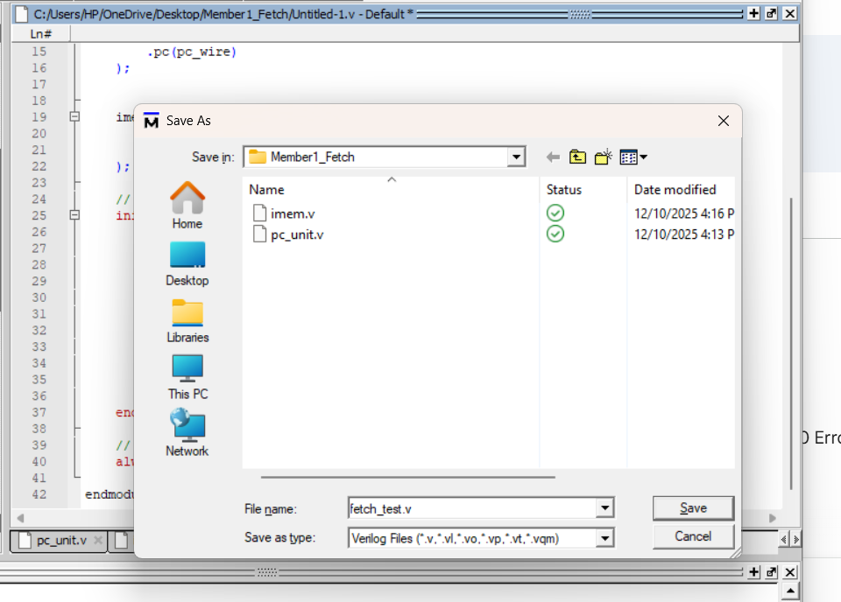
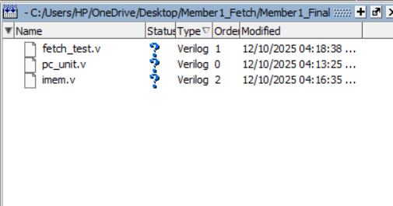

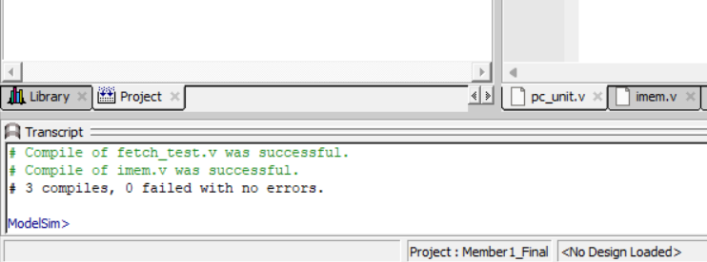

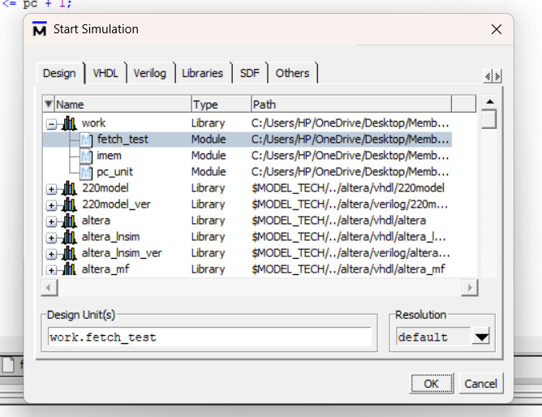
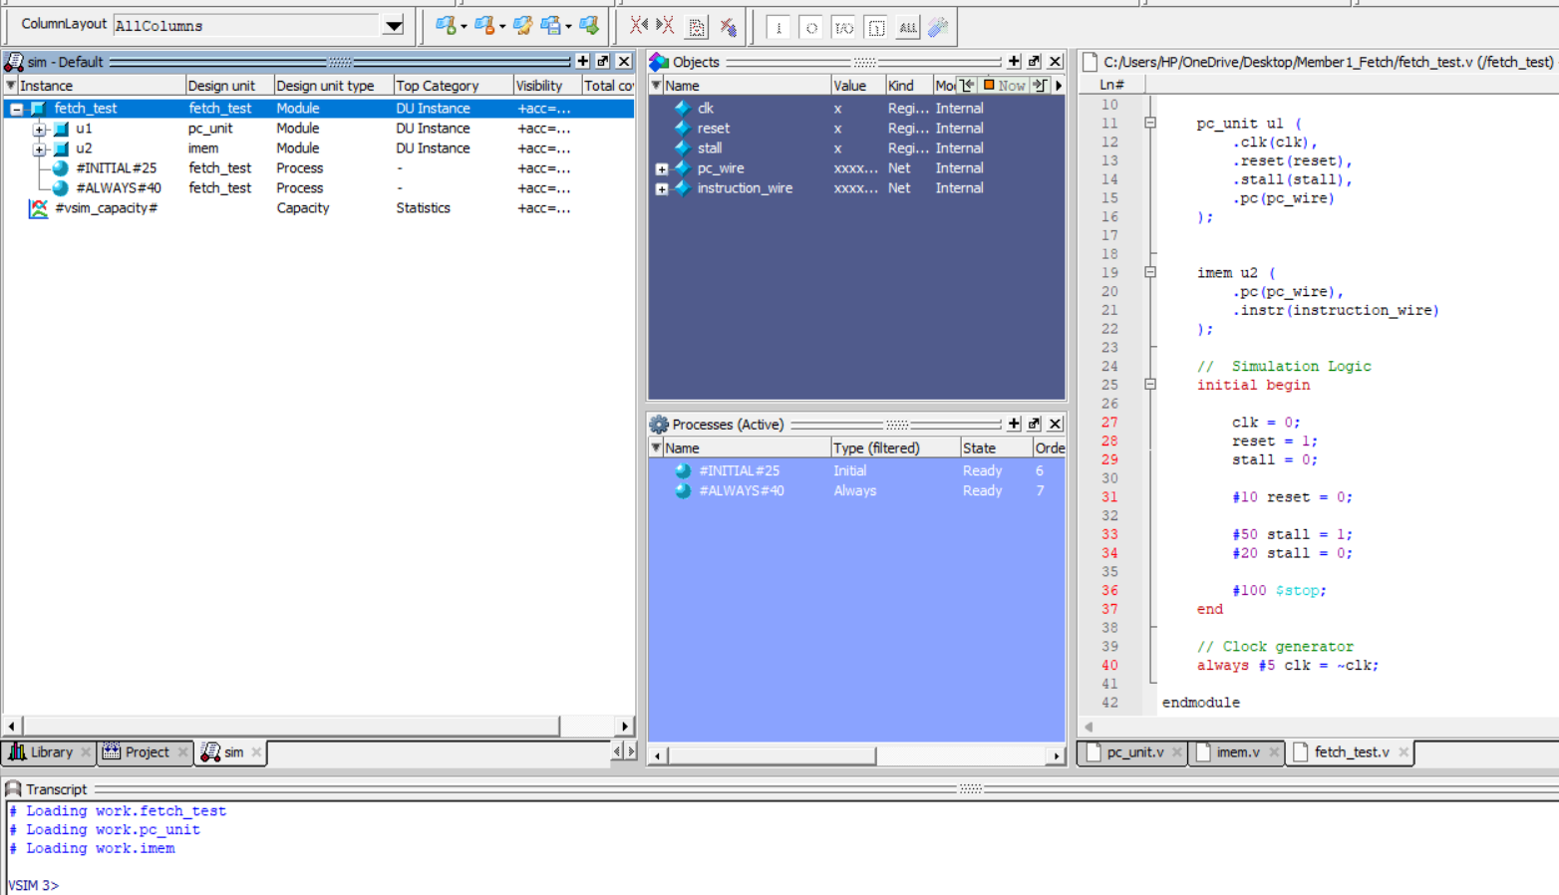
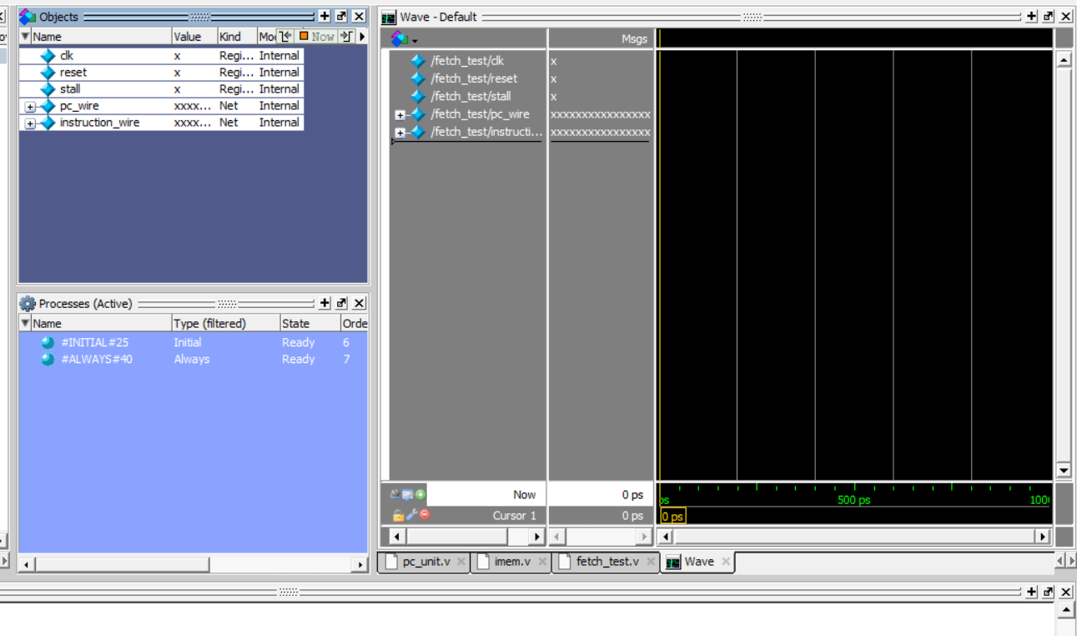

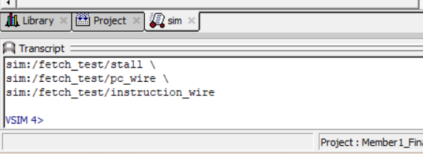
After run 200
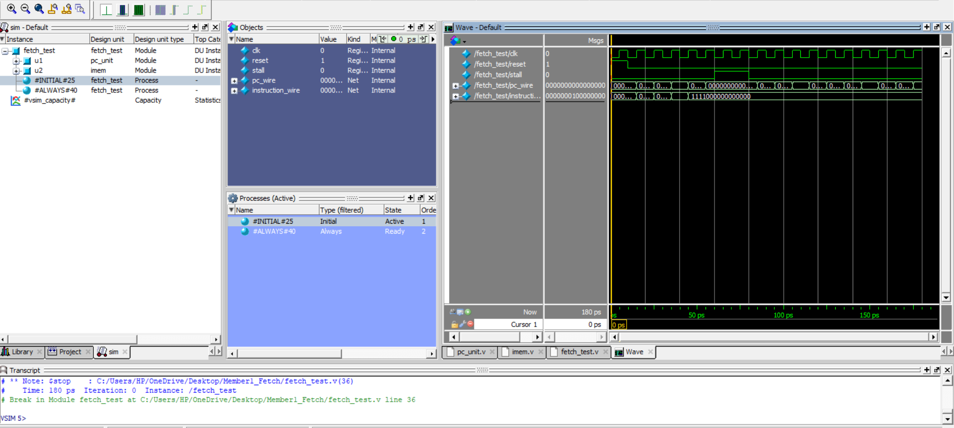

Second stage:
Decode Stage Implementation Documentation
Executive Summary
Implemented the Register File module for the 3-stage pipelined RISC-V processor decode stage. The module features 16 16-bit registers with dual-read, single-write capability and synchronous reset functionality.
Technical Implementation
Module Specifications
- File: reg_file.v
- Registers: 16 × 16-bit array (R0-R15)
- Interface: 2 read ports, 1 write port
- Clock: Positive edge-triggered
- Reset: Synchronous active-high
Creating file 1:
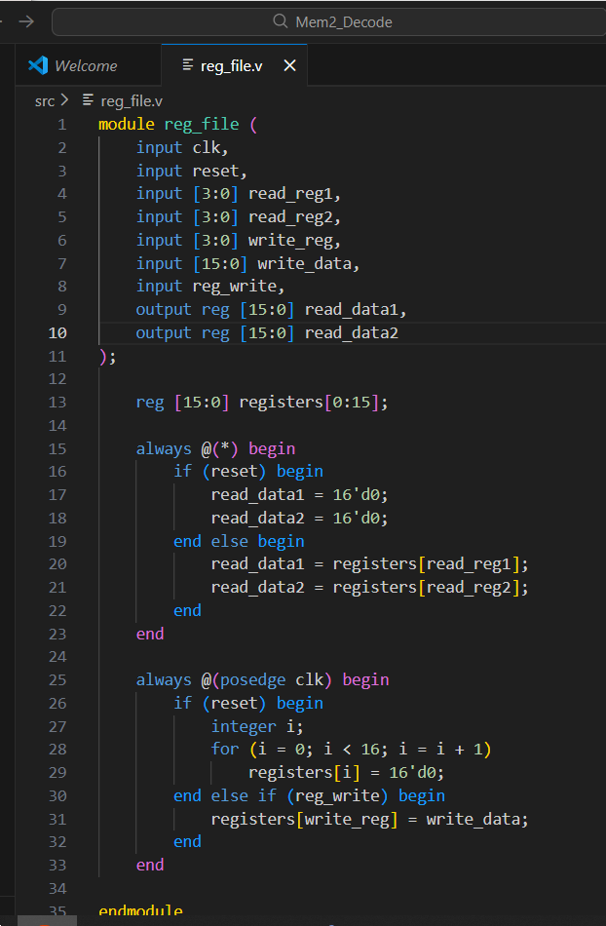
Creating file 2 for testing:
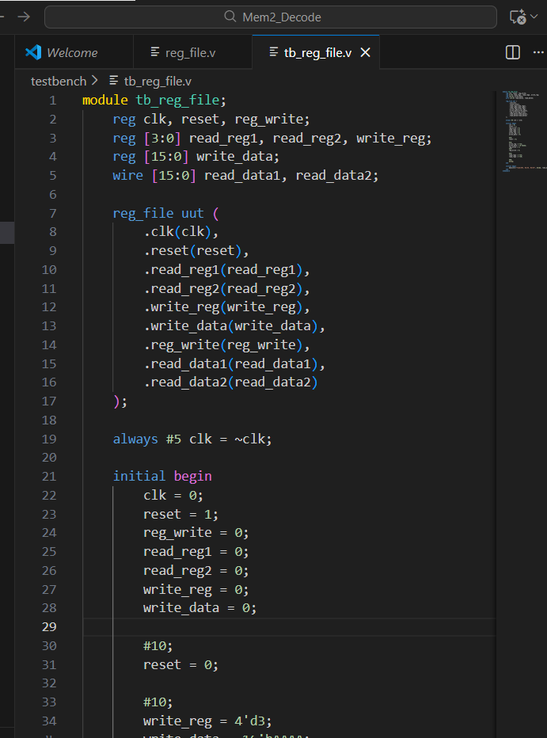
Compiling all the files in Verilog:
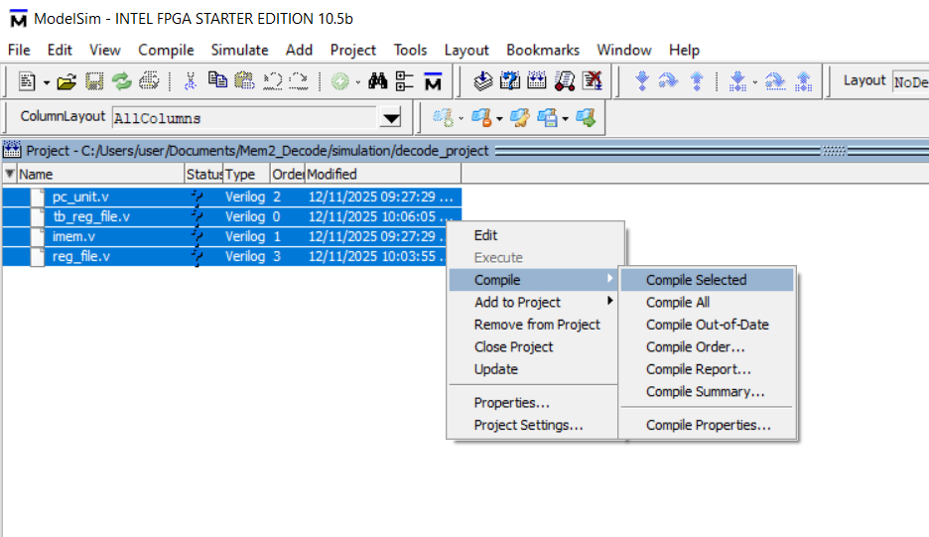
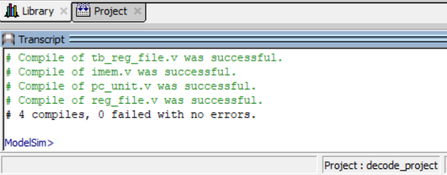
After successful compilation of all files, begin with simulation and add the wave signals and observe the wave diagram:
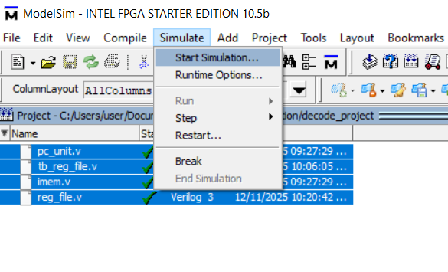
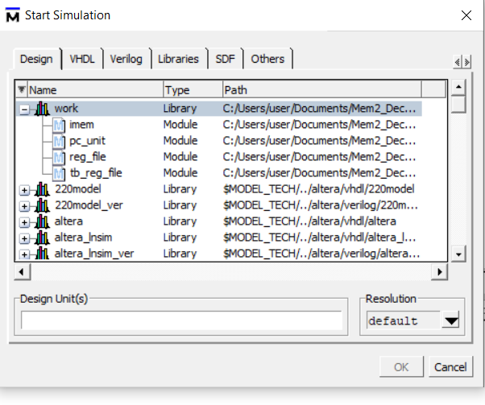

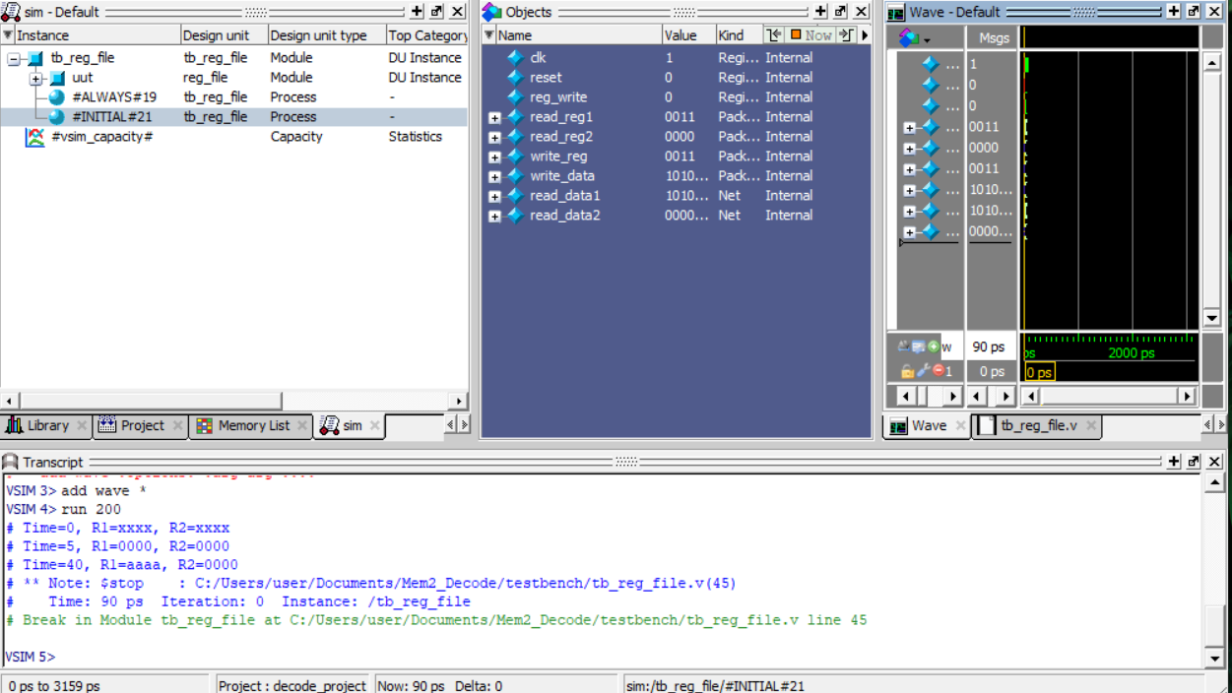
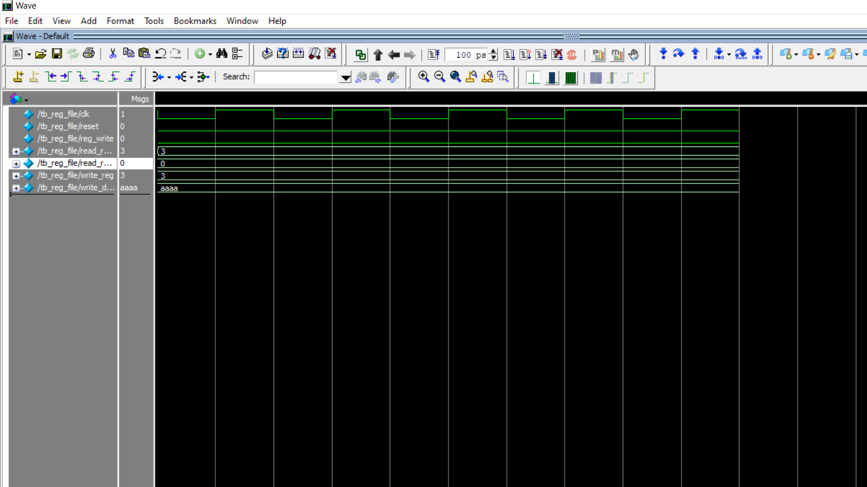
For the signal verification in Verilog, change the following signal configuration:
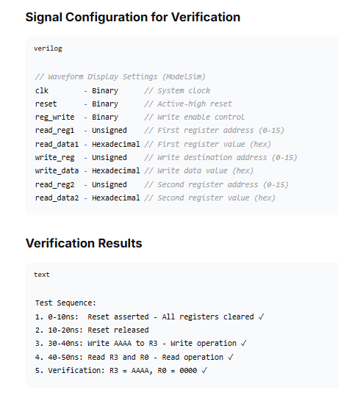


Stage 3 :Execution Stage

Description
This stage is responsible for executing the instruction and managing the connection of outputs from previous stages. In our project, Member-3 mainly focused on integration and proper working of the processor, instead of implementing many ALU functions separately.

Files Implemented :
- alu.v – Basic ALU structure available
- processor.v – Most important module (Top Level Integration)
- tb_processor.v – Testbench for complete processor verification
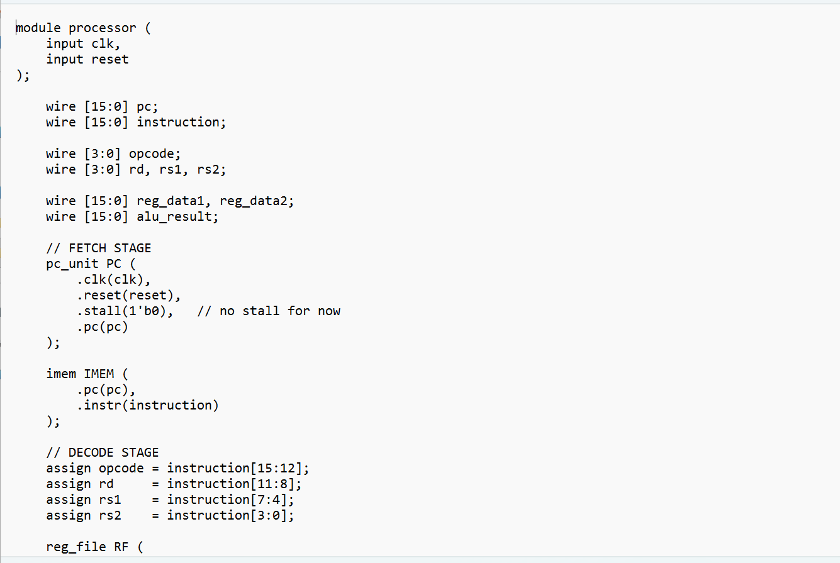
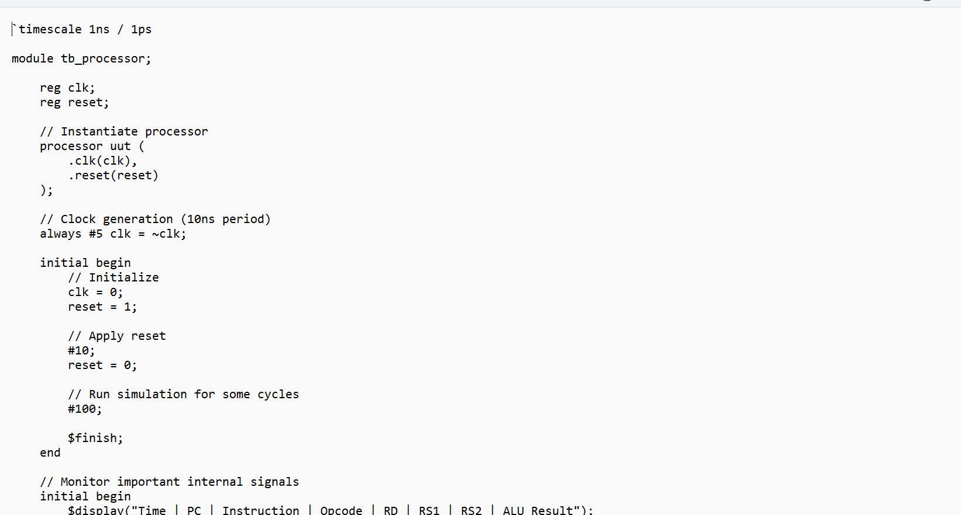
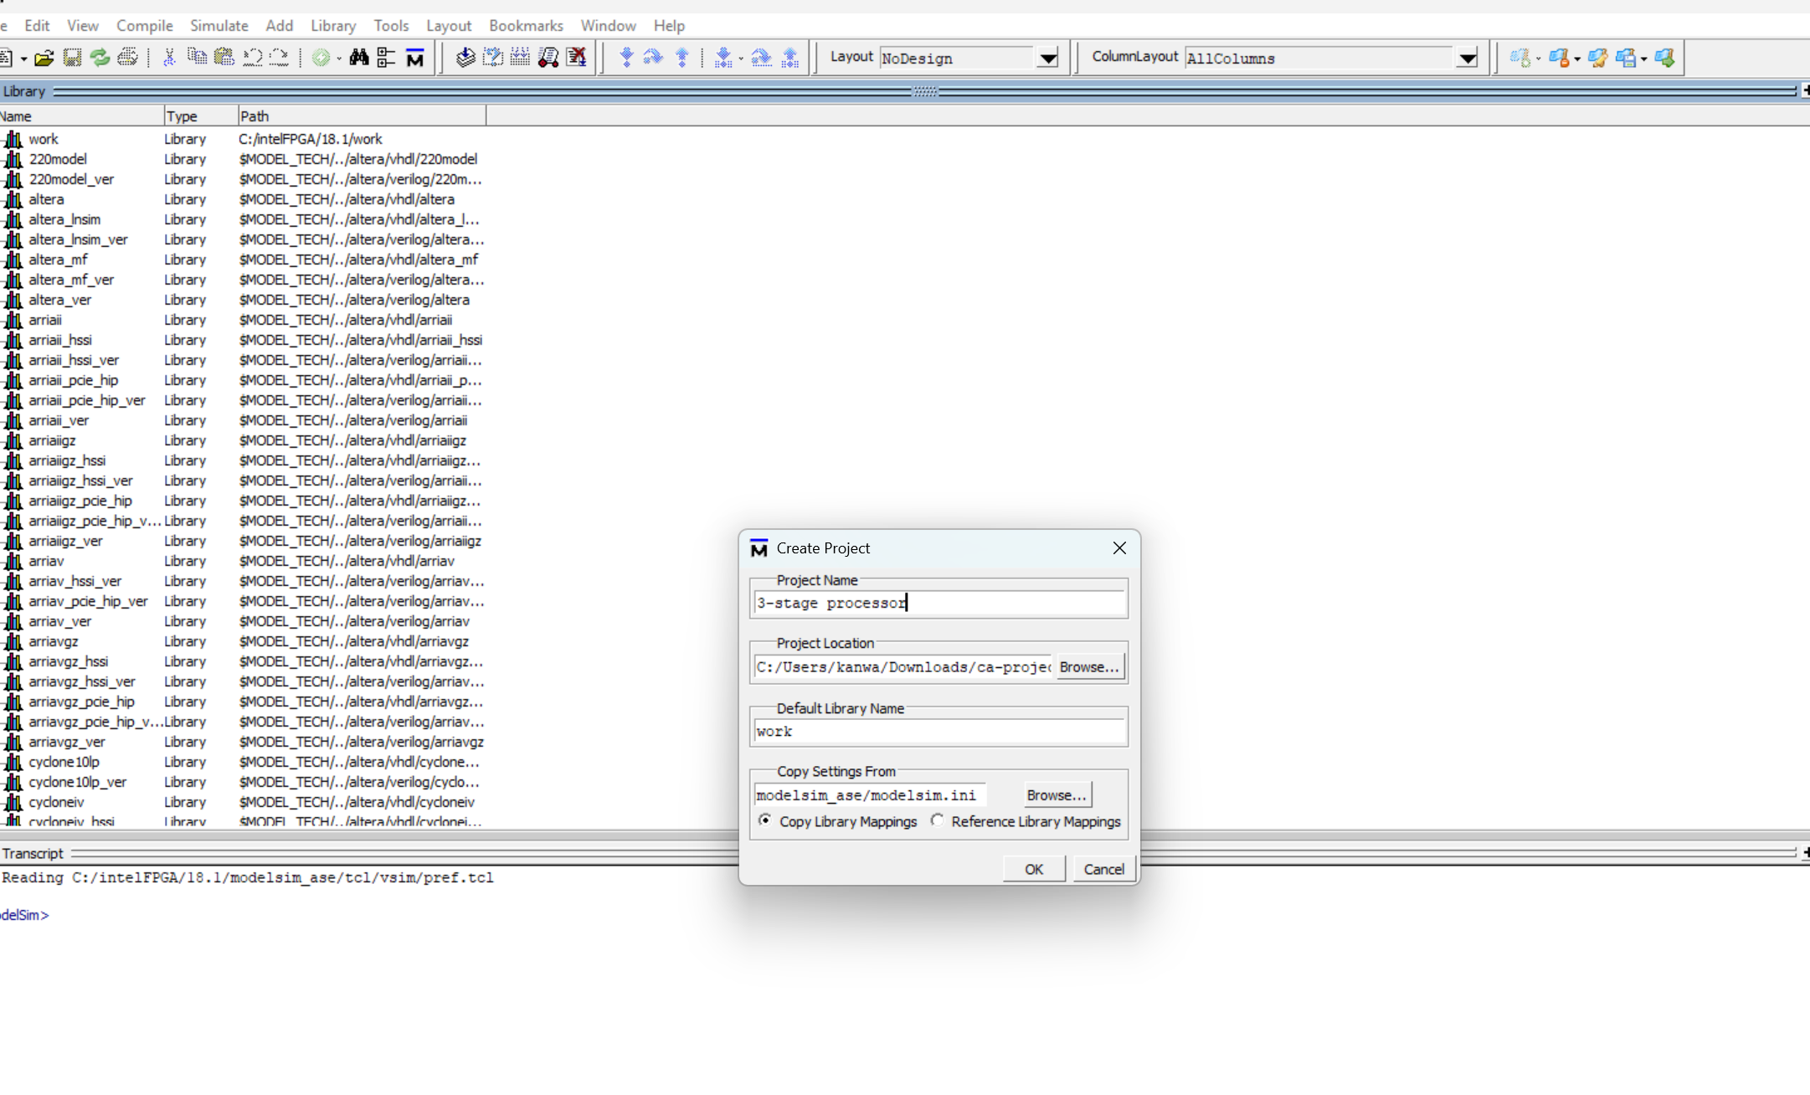
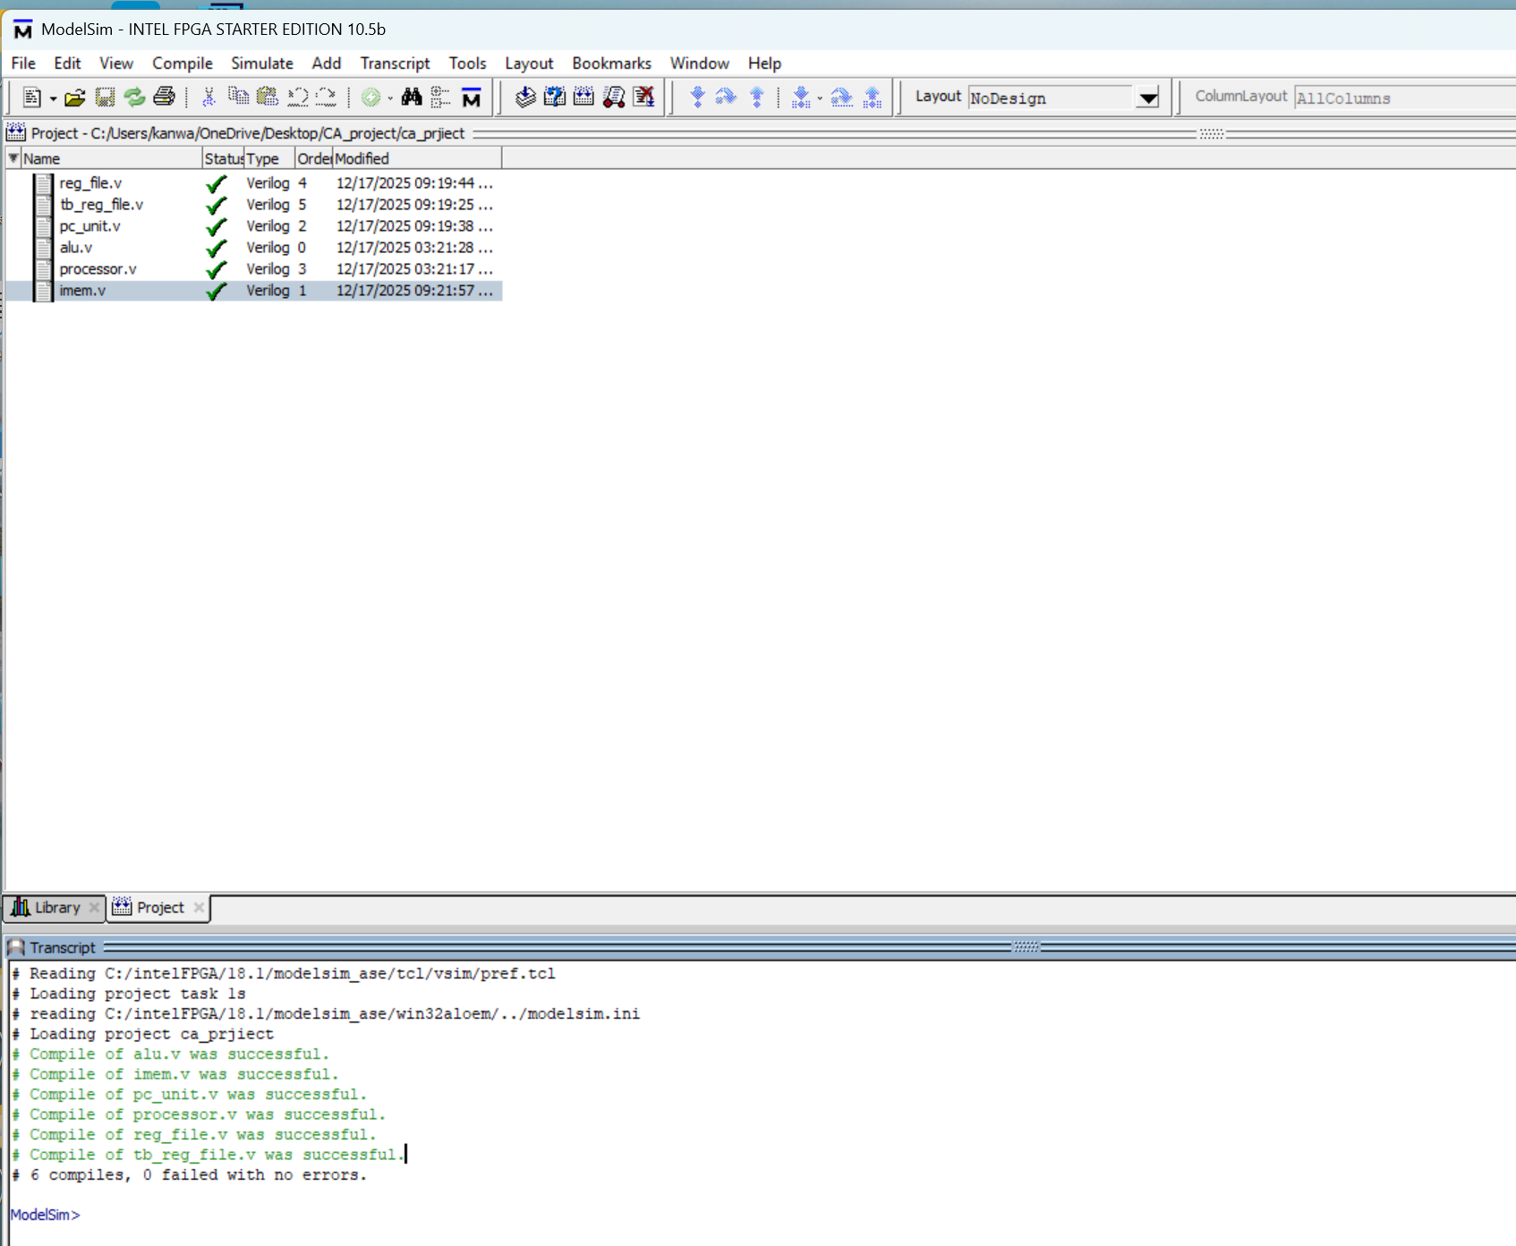
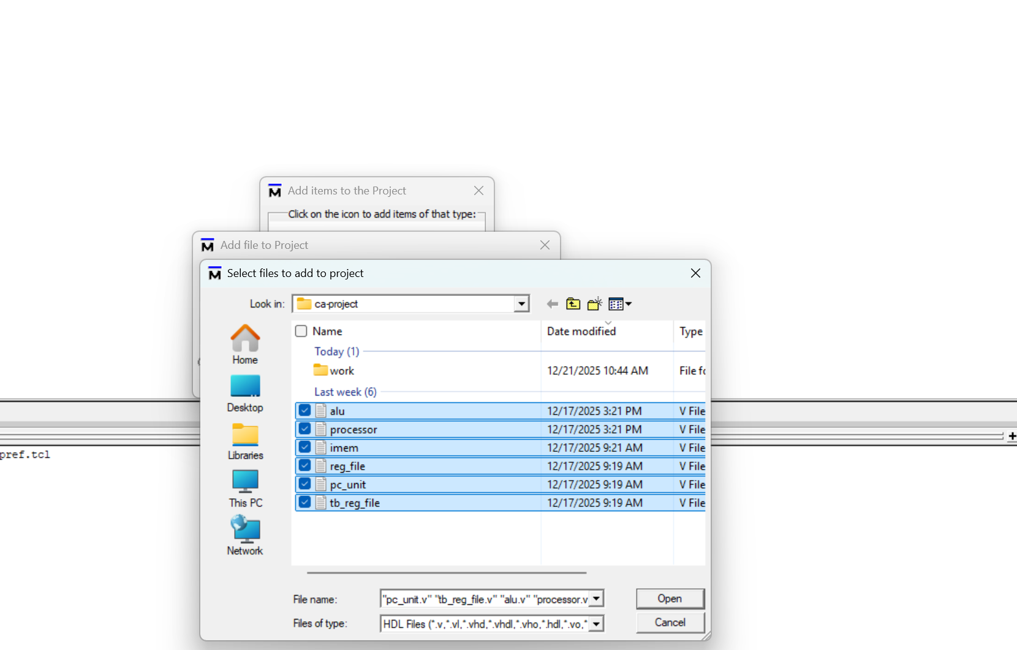
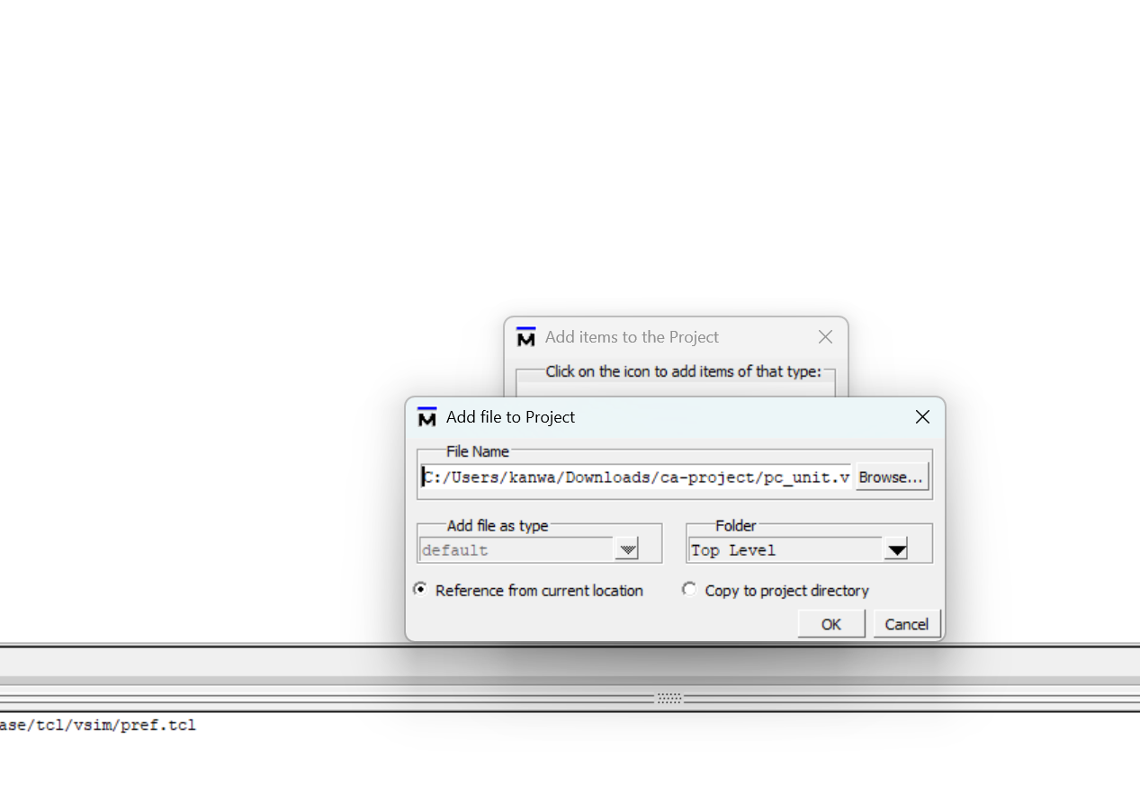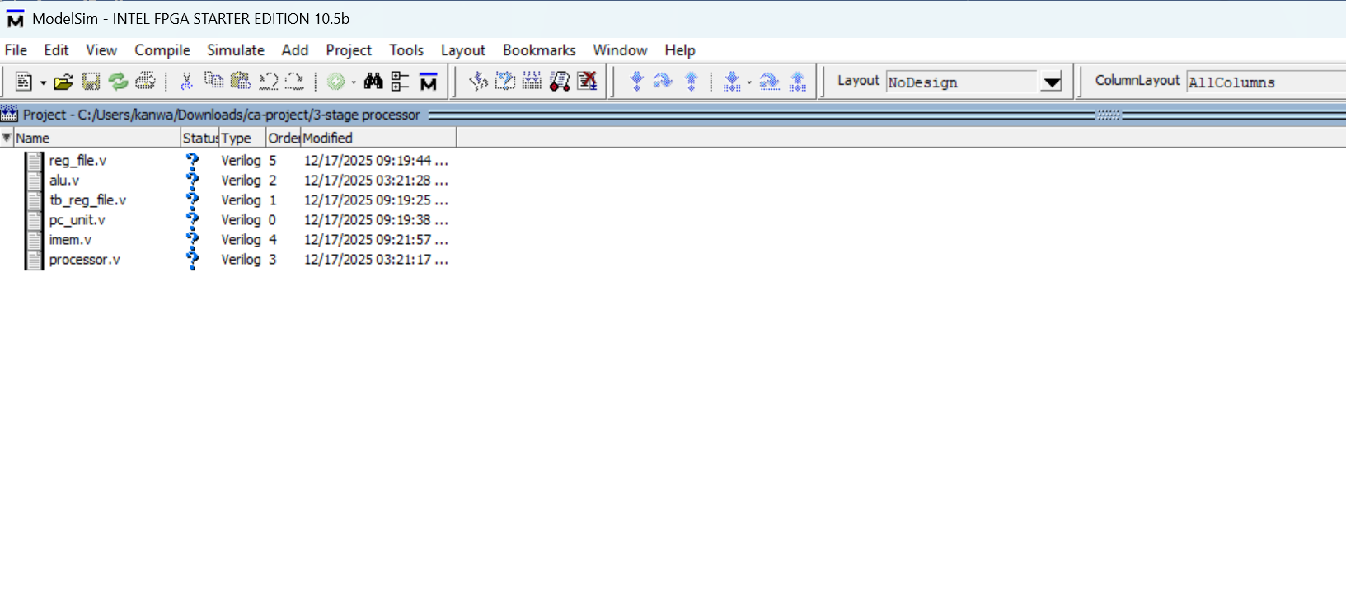
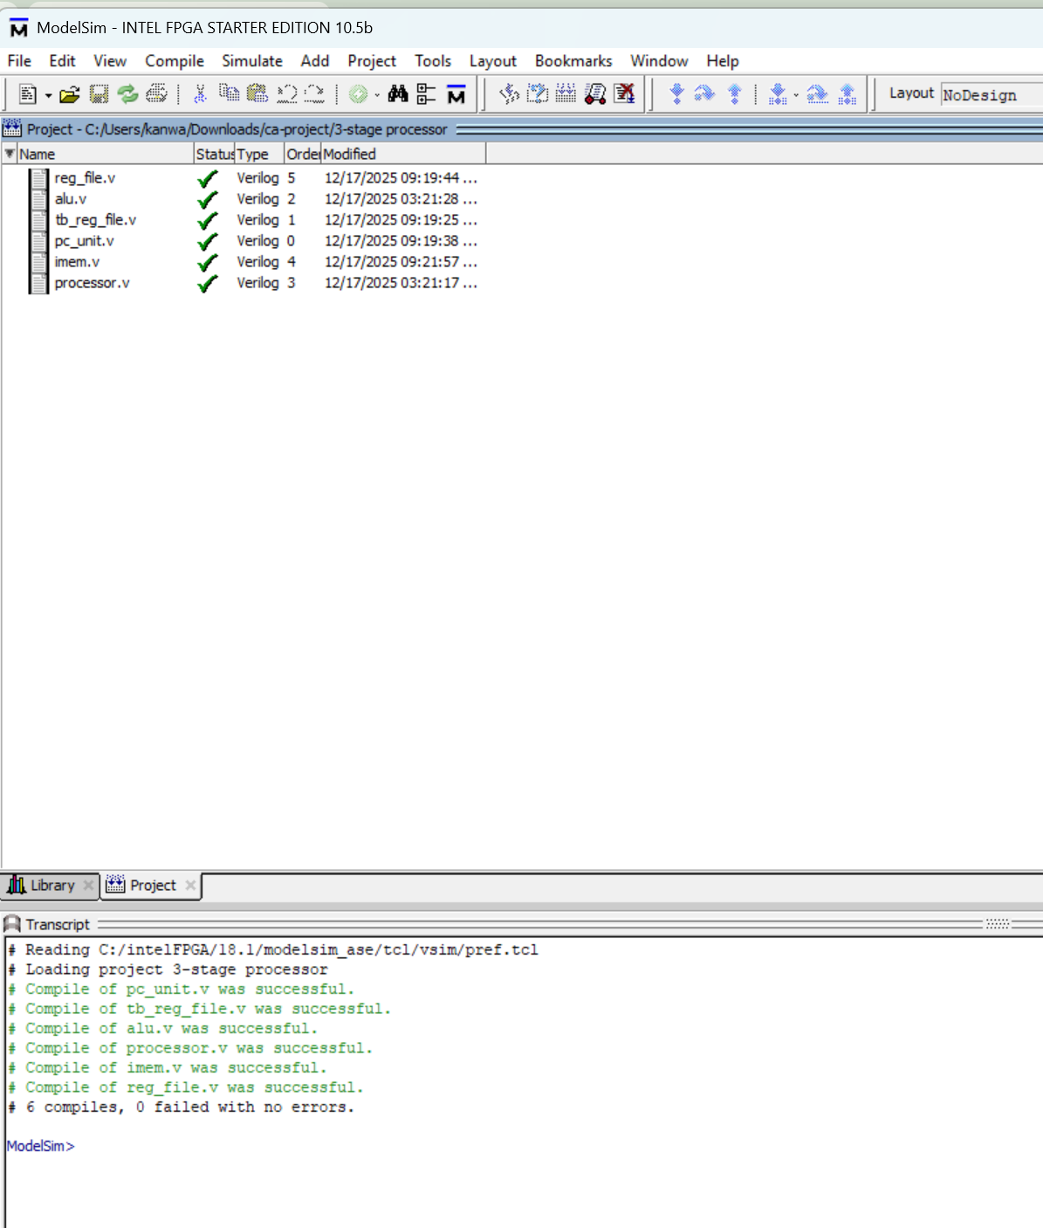
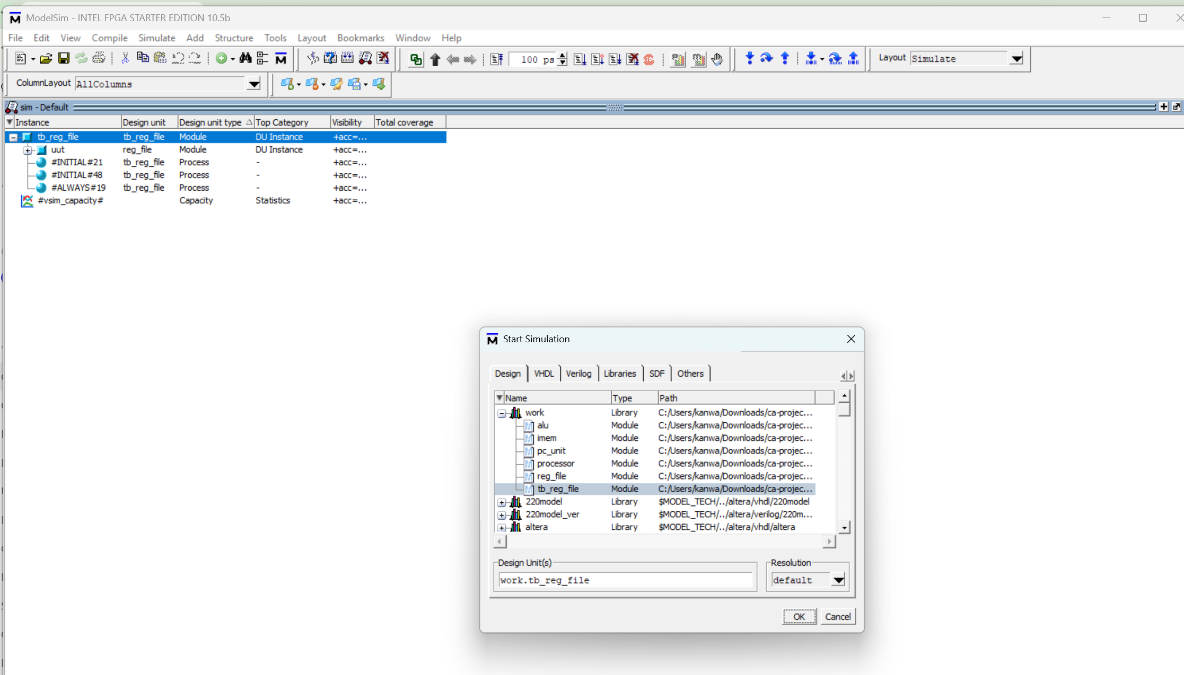
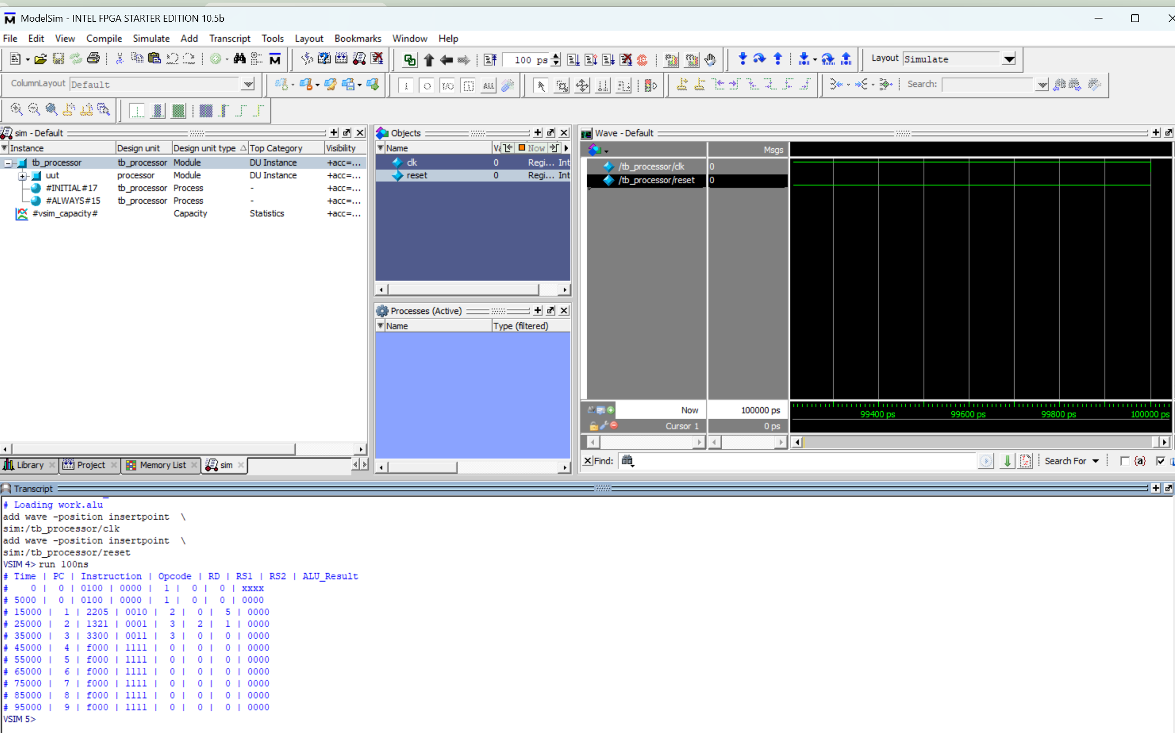
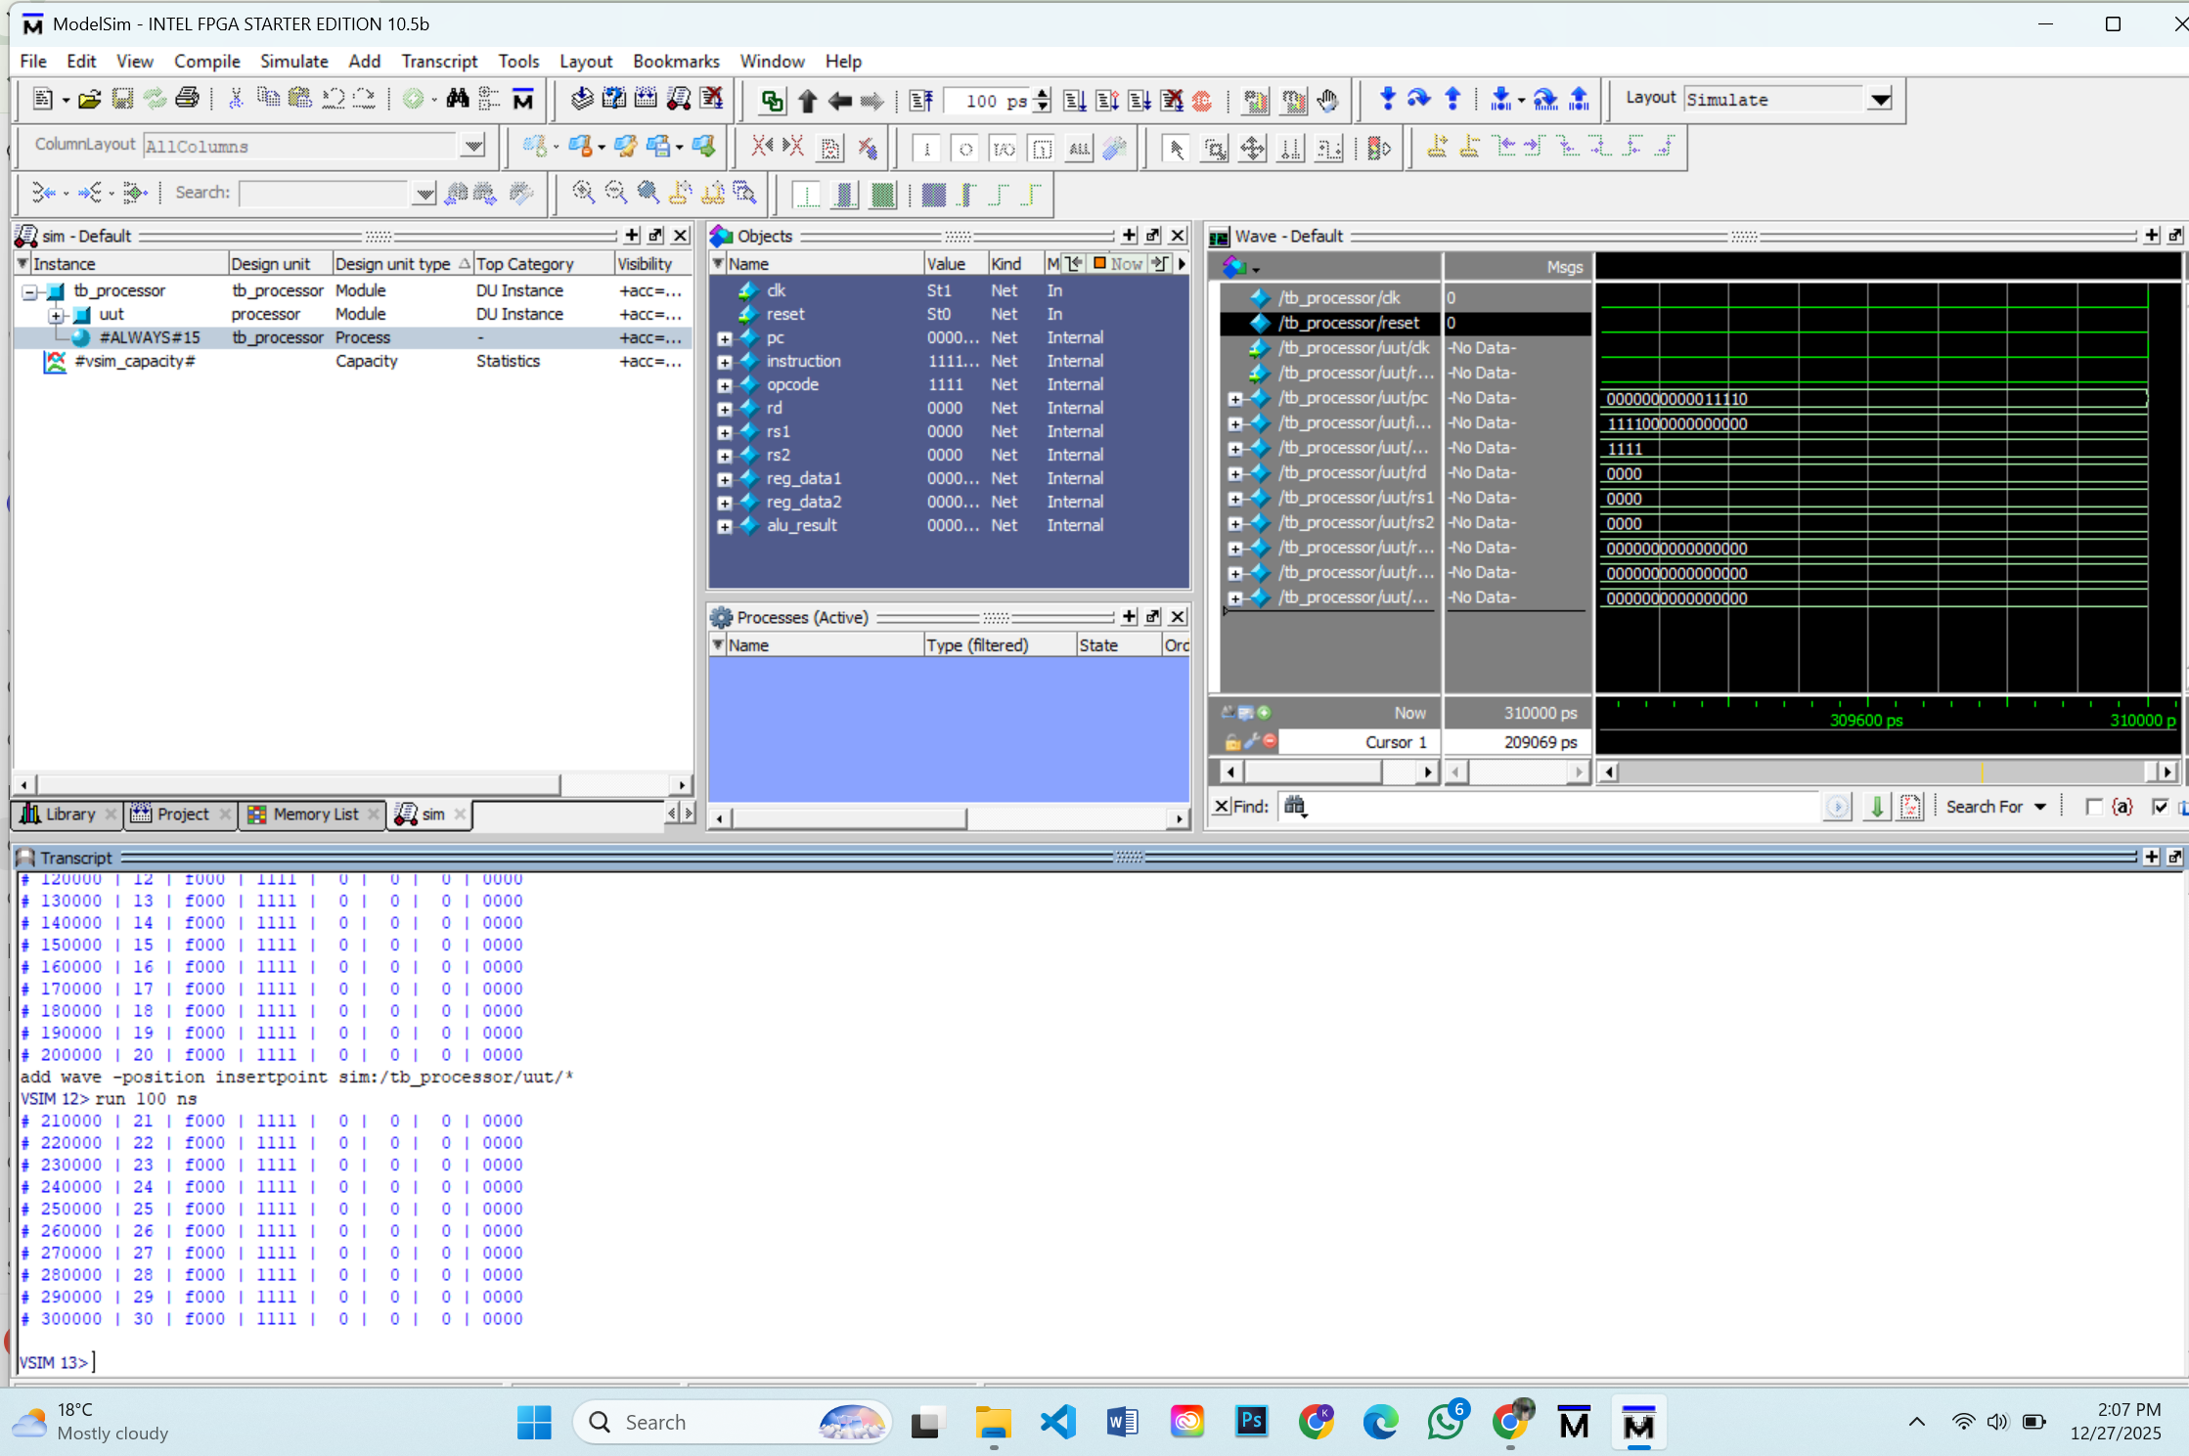


Conclusion
We successfully designed and simulated a 3-stage pipelined processor. The design handles basic arithmetic and memory operations. This project helped us understand Verilog HDL, modular design, and computer architecture concepts like data flow and hazard handling

